SUBMISSION -4

NAME: VIDISHA GROVER

CODE: GSBSP-BR52

This page includes **CONTACT US** section and in addition a **RESERVATION** section . These two sections are created using forms and buttons from BOOTSTRAP. This page also includes **MENU CARD.**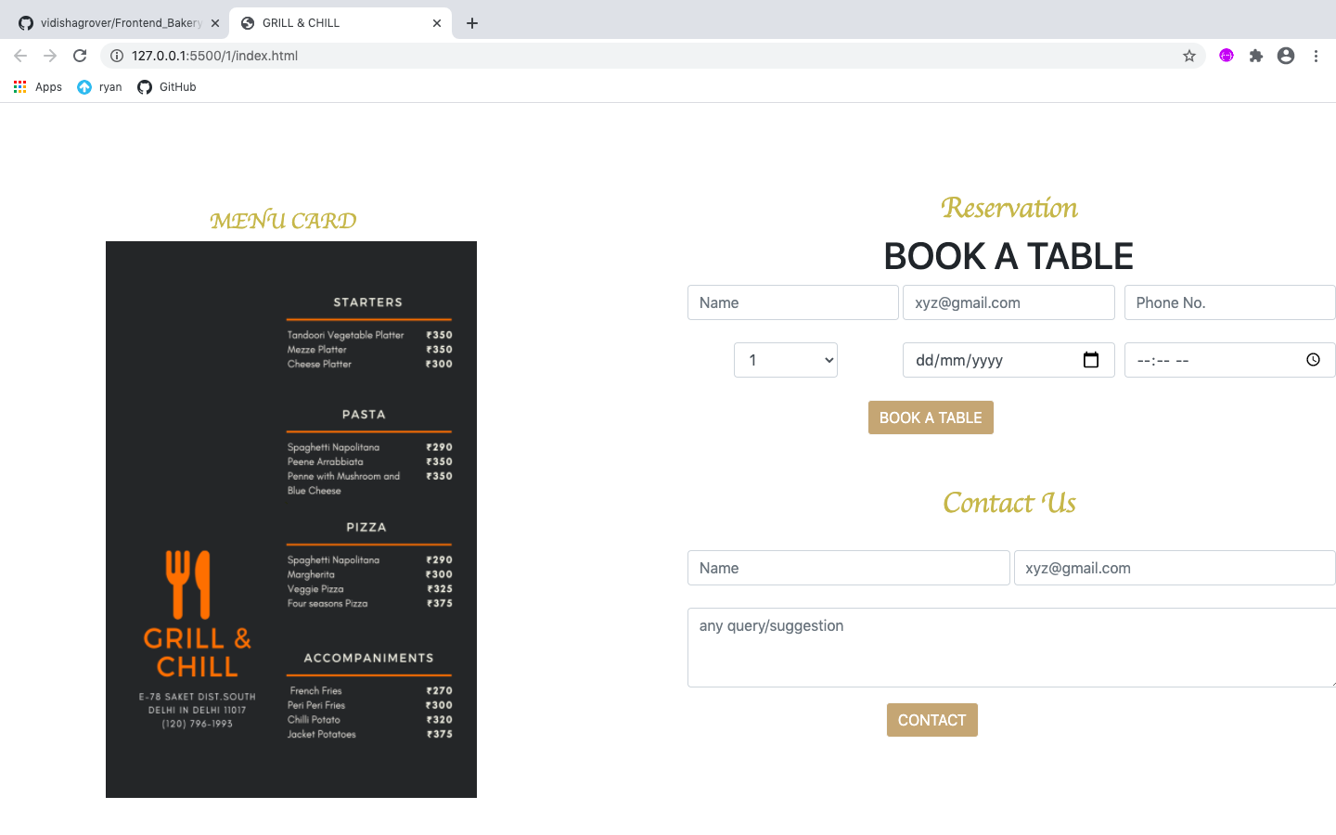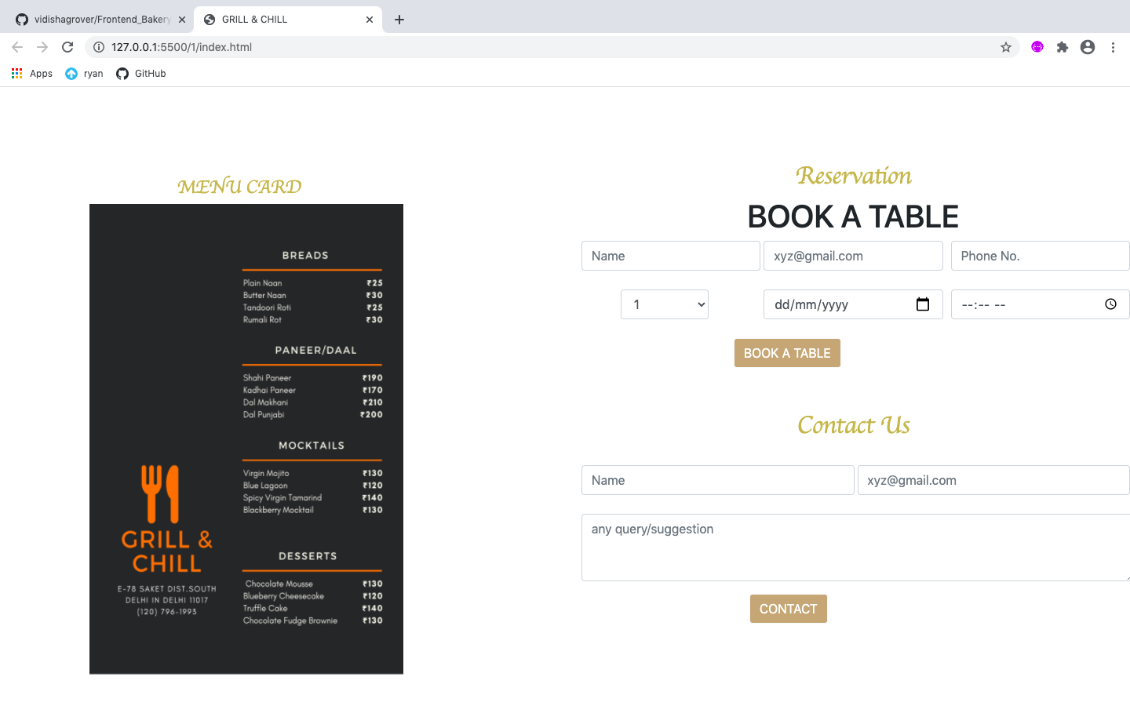

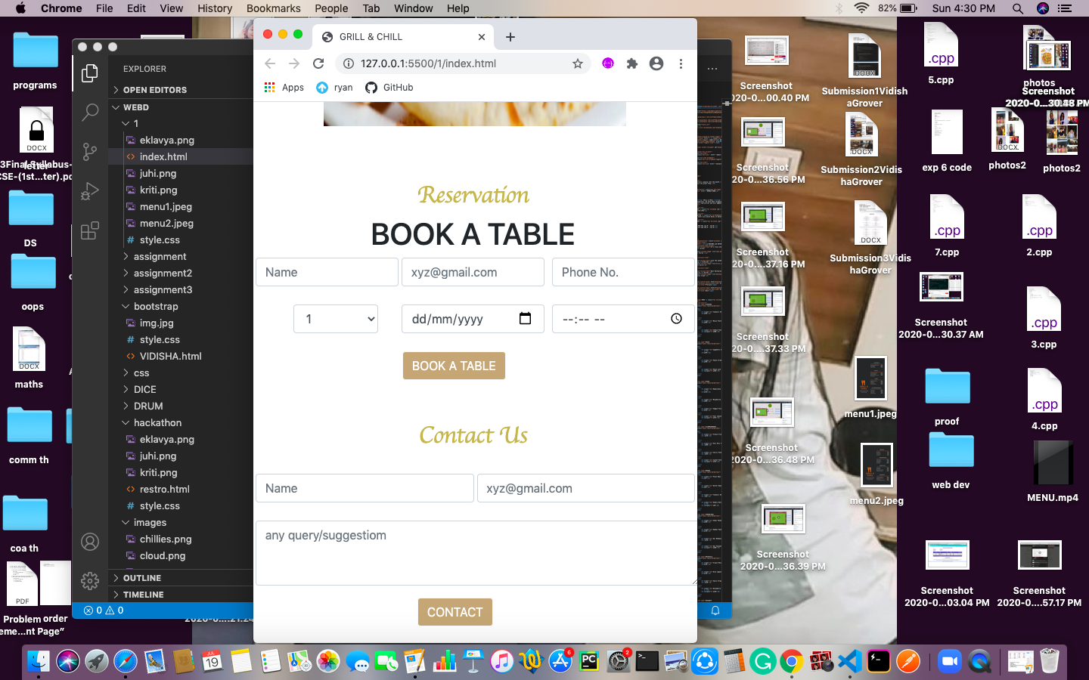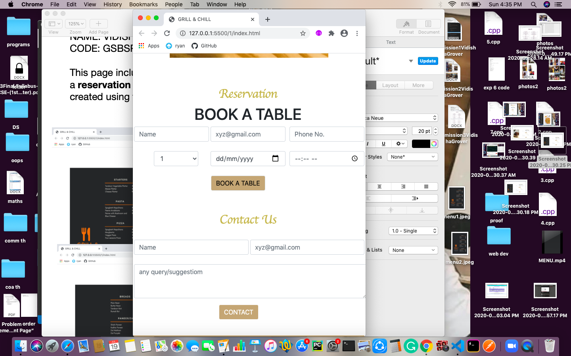

Hover property is also added to these buttons.

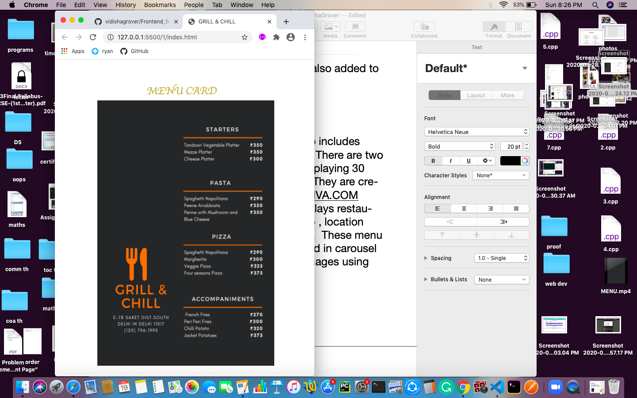

This page also includes **MENU CARD .** There are two menu cards displaying 30 dishes in total. They are created using [CANVA.COM](http://CANVA.COM)which also displays restaurant name, logo , location and contact no. These menu cards are placed in carousel along dishes images using BOOTSTRAP.

A carousel is placed just beside reservation and contact us section which have dishes image which have been used from [PEXELS.COM](http://PEXELS.COM) .

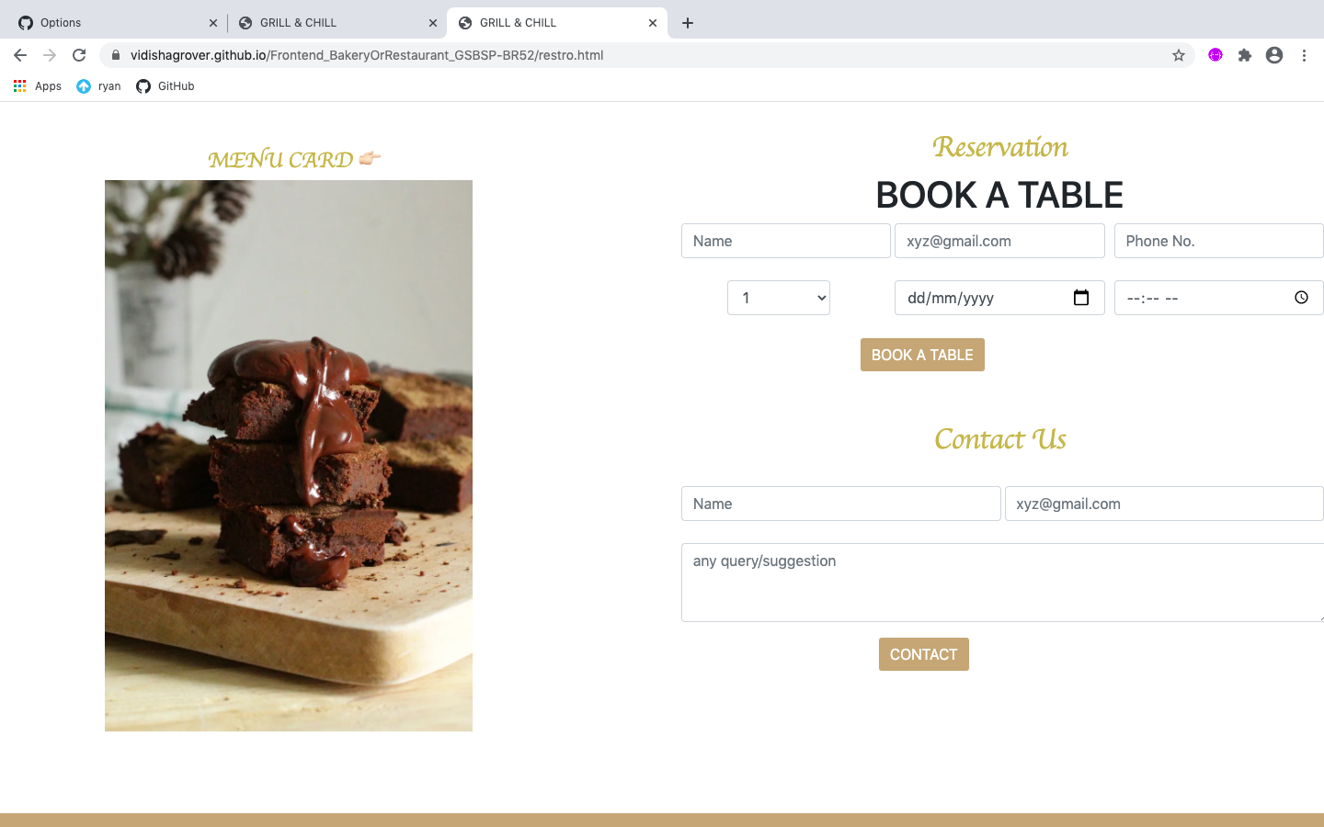

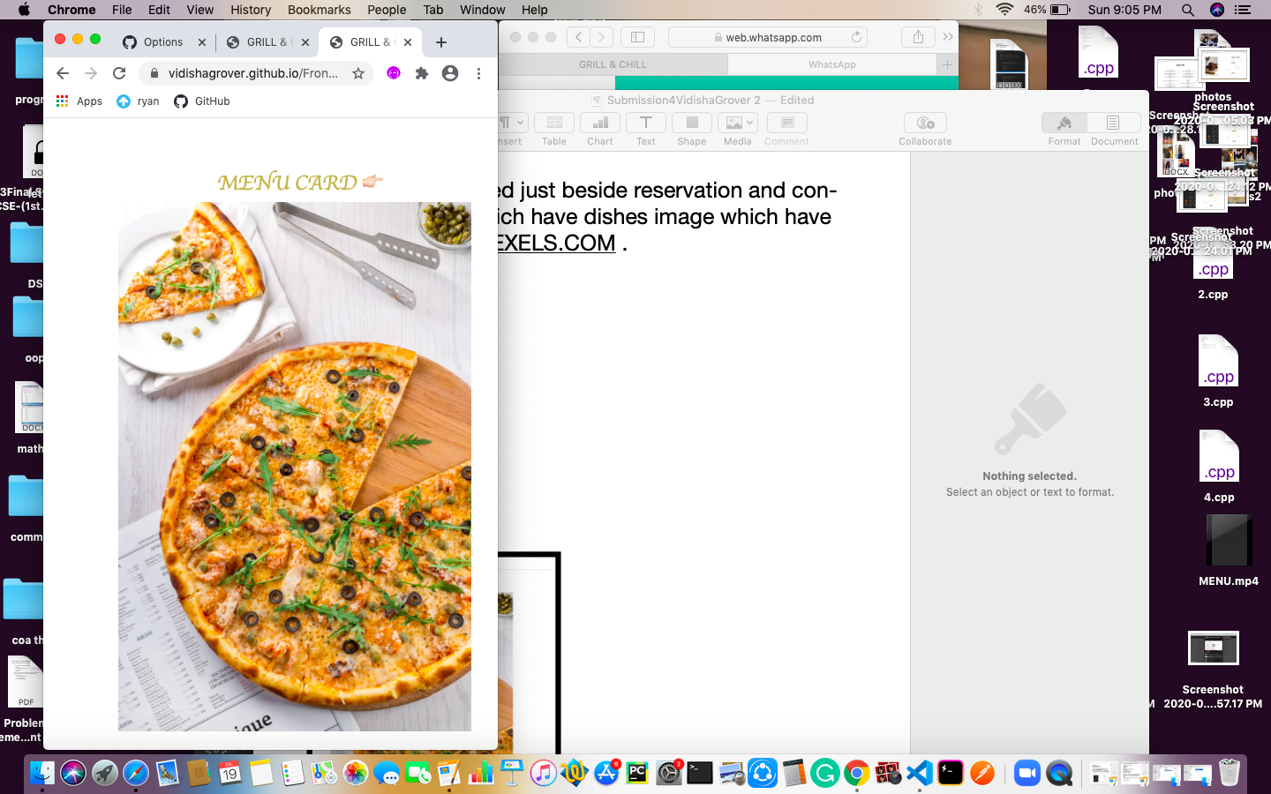

Just below contact us page we have **FOOTER SECTION** which says Ⓒ Copyright 2018 GRILL & CHILL and particularly for restaurant name font is used from GOOGLE FONT and it also comprises icons to contact or get linked. Icons have been taken from [FONTAWESOME.COM](http://FONTAWESOME.COM) . These icons are placed for contacting whereas for fulfilling **contact us point** a section has already been made and some details have been provided in about section also and icons are added just to make it little more attractive.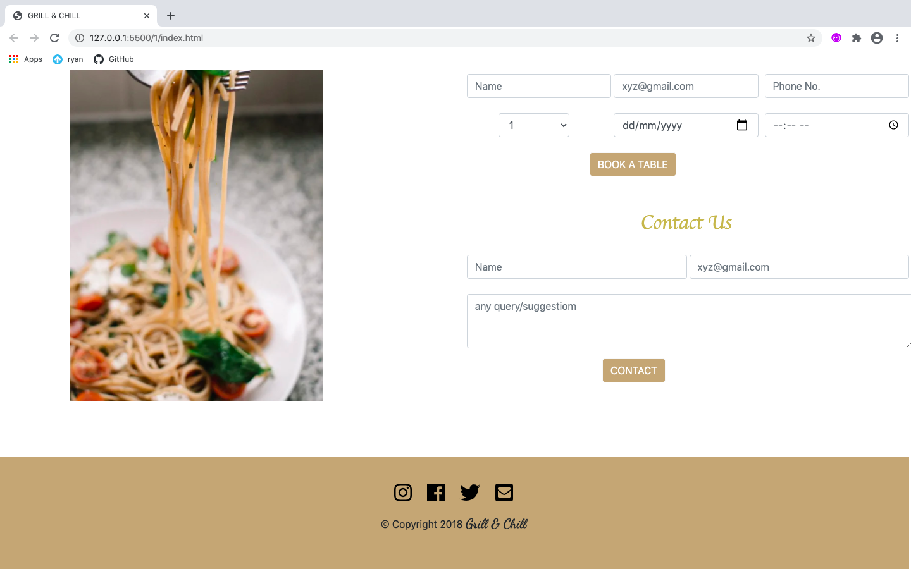

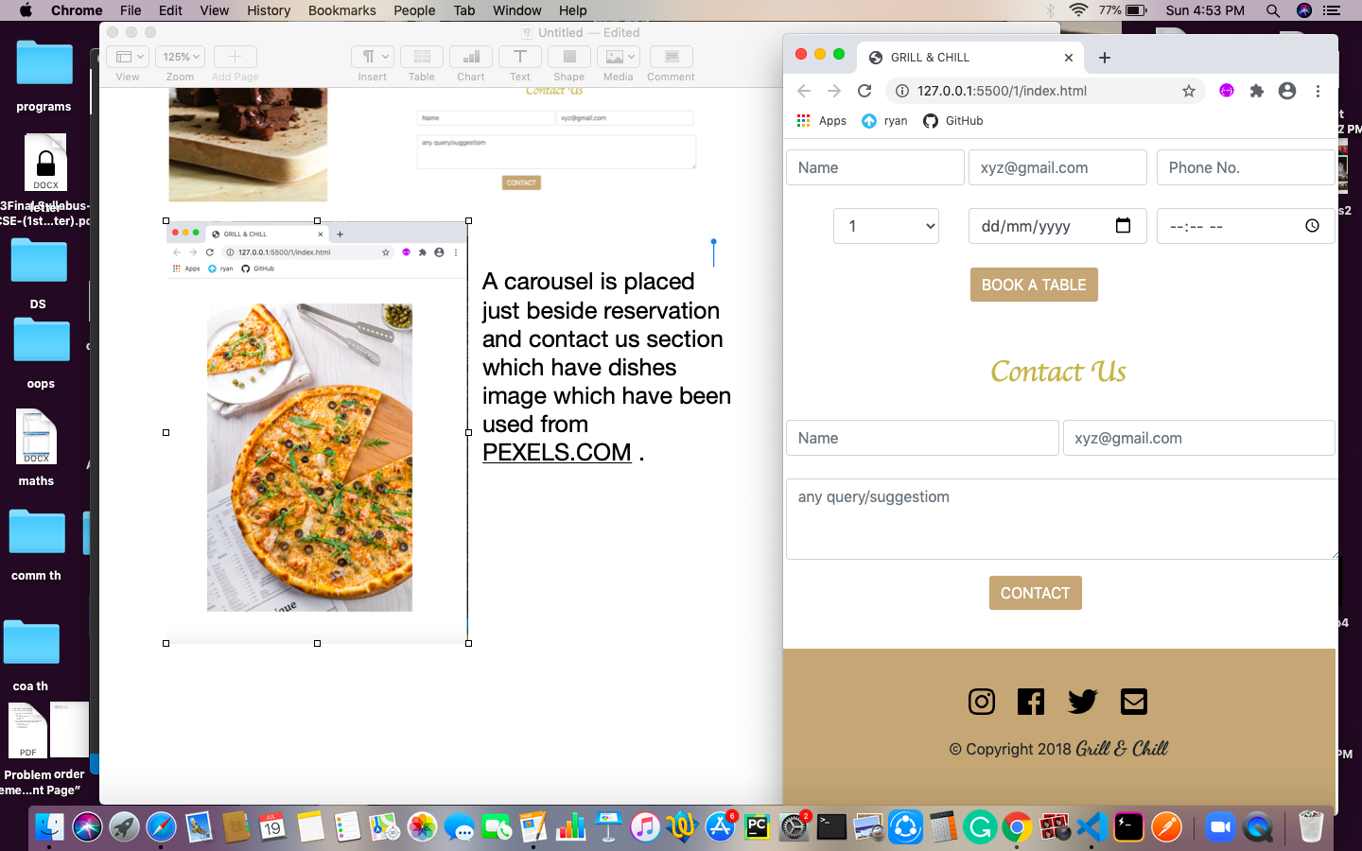

Hover property is also added to these icons.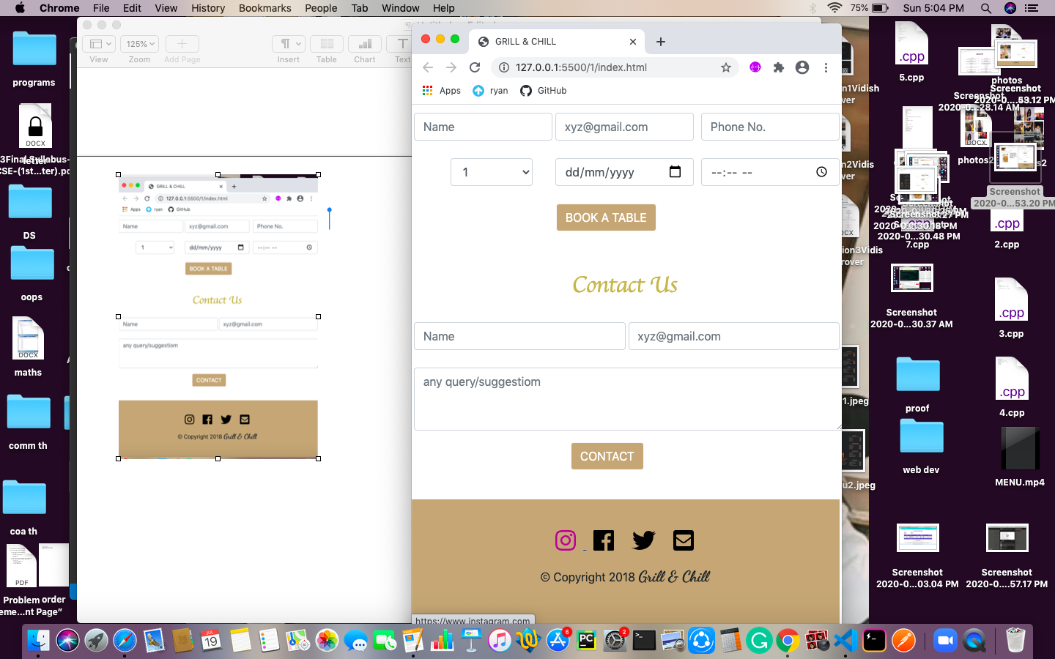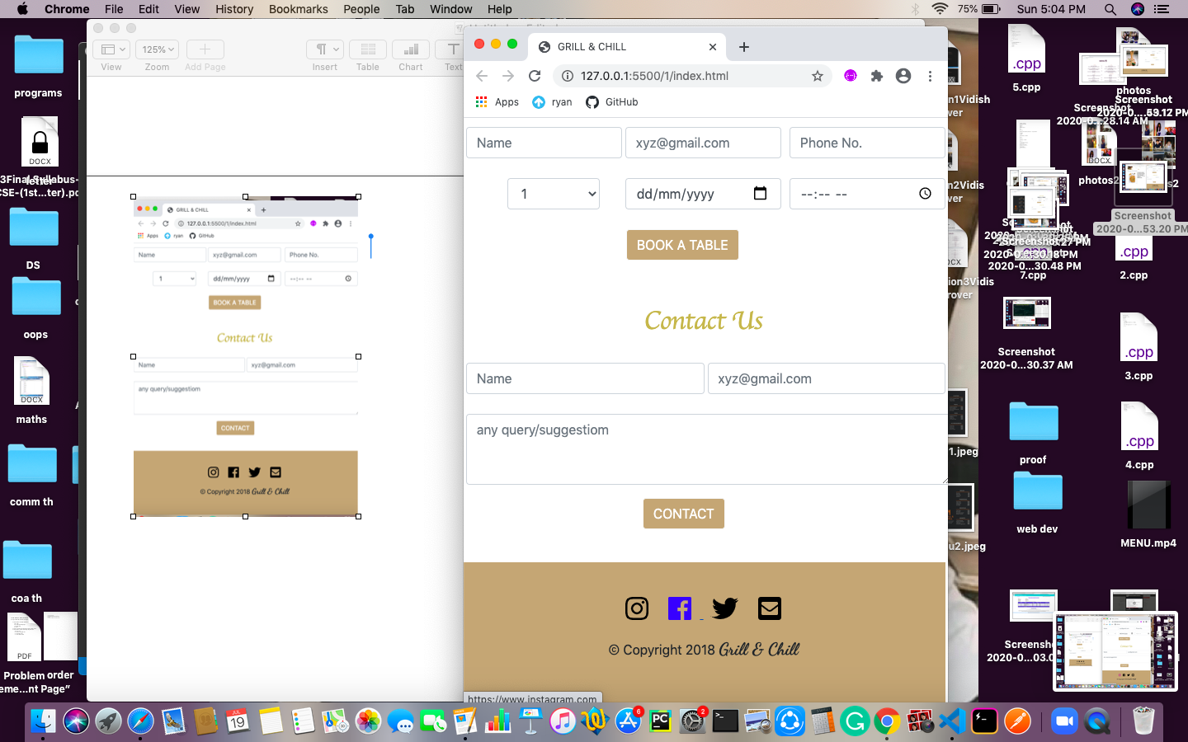

Except HTML & CSS codes I have used BOOTSTRAP for buttons , forms and carousel , GOOGLE FONTS for some wonderful fonts , FONTAWESOME for creative icons to enhance my website , PEXELS to add some beautiful pictures and JSS for carousels.

ALL POINTS ARE COVERED :

1. NAV BAR
2. HOME PAGE
3. ABOUT
4. FOOTER
5. 30 DISHES WITH CONTENTS
6. MENU CARD
7. CONTACT US SECTION
8. COMPANY LOGO
9. BUSINESS LOCATION

THAT’S ALL FROM MY SIDE . I TRIED MY BEST AND THANK YOU TO THE TEAM FOR ORGANISING THIS HACKATHON. IT WAS SO FUN TO BE PART OF THIS EVENT.

👉🏻<https://vidishagrover.github.io/Frontend_BakeryOrRestaurant_GSBSP-BR52/>restro.html👈🏻

* my repository link